In groups we trust

A Community Spirit revival will revolutionise where, and how, people live

As citizens lose trust in institutions across Europe and the US, they’re placing more faith in family, friends and other peers.

The trend’s set to revolutionise the way households, living spaces and communities are organised, built and run.

Next Big Thing
October 2020
Key insights from the report

As levels of institutional trust continue to tumble, individuals are increasingly seeking out the physical and emotional support of their peers. The report shows how more and more people are surrounding themselves with a trusted “framily” of relations, close friends, neighbours, work colleagues and members of shared interest groups. And how greater value is being placed on interpersonal relationships and communication, social leisure and peer-driven decision making.
It explores how Covid has accelerated the trend. Local communities and online friend networks provided vital physical and emotional support for those in lockdown, and were acknowledged for doing so.
The Community Spirit trend has major implications for the future. It’s set to impact where, and how, people are going to live; what they’ll need to do so; and how they’ll want their communities to be run.
The report predicts three major developments coming out of the trend.

______________________________

1. Household composition will be transformed
More and more people are starting to see the value of shared living space. After decades of shrinkage, it looks like household size is about to rise again. A desire for communality is one of several factors driving growth in three generation households. Flat sharing is increasing too, not just among the young or low income. And co-living and Live Work Play spaces are more and more popular, especially among the hugely pro-community Millennials. Think dorm-style developments, streaming subs-driven entertainment rooms and shared kitchens, with consequent opportunities for retail and restaurant sales and sponsorship.

2. Local neighbourhoods will take centre stage
People today place more value on their day to day environments and work/life balance. Combined with a likely rise in home working, this is starting to drive citizens to take greater interest in their local neighbourhoods, and seek more influence over them. This will pave the way for walkable ‘15 minute cities’ and growth in bicycle and e-bike sales.

Poynter Institute, Media Trust Survey, Aug 2018

There’s likely to be more space on the High Street for local entrepreneurs, and more sharing of goods between neighbours. Companies will need to ‘act local’, as residents prove warier of ‘outsider’ brands. But there will be more opportunities to drive local loyalty by sponsoring neighbourhood amenities. The trend could also drive a shift away from cities towards more suburban and rural living, as people begin to value good local amenities over an area’s proximity or transport links to big population centres.

3. Communities will become more autonomous
Today’s technologically-enabled citizens are increasingly protesting government, institutional and business influence over their lives. For many, this is manifesting in an attempt to take back control over local institutions and planning. As this grows, we’ll see more place shaping: close citizen involvement in local development. Some co-living spaces and neighbourhoods could even develop into self-sufficient ‘bubbles’, determining everything that happens within their boundaries. The more influence residents gain over their neighbourhoods, the more they’ll seek power for them. This could drive growth in citizen-led autonomous communities, from prepper groups and micro-communes to Seasteading communities and even city states. Networks that develop between these communities could have a huge influence over national and global politics.

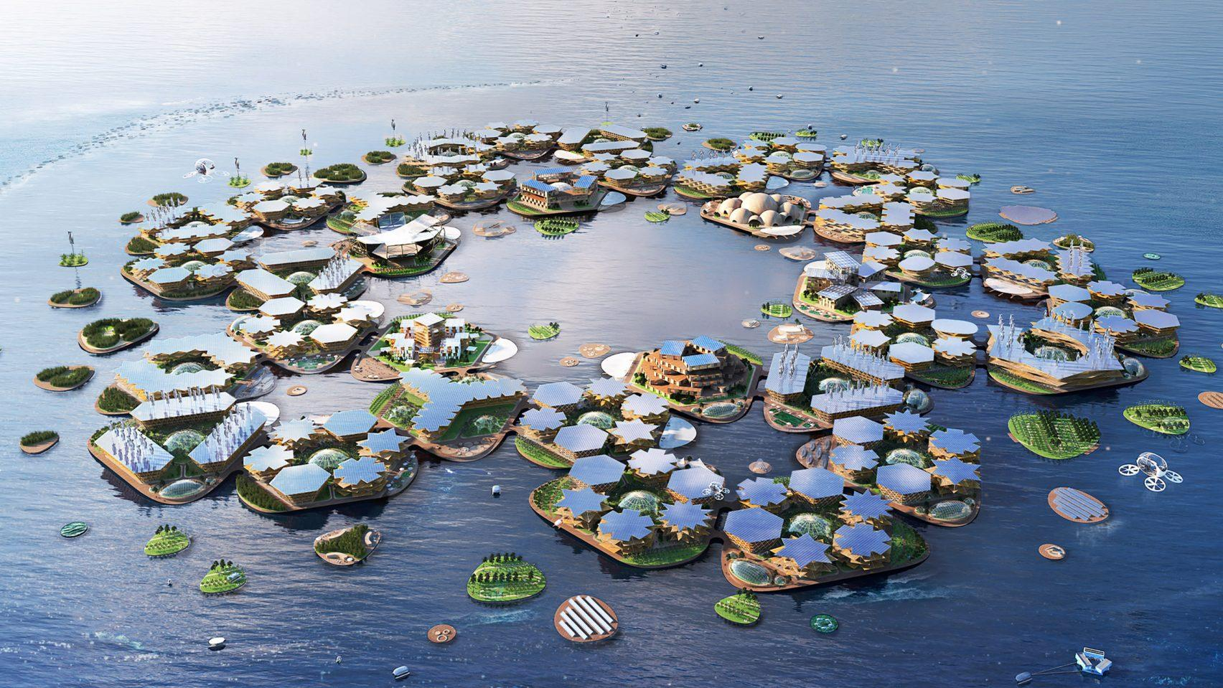
Seasteading could create huge brand new cities like ‘Oceanix’.

______________________________

The report also looks at what these changes will mean for business. How, for instance, more autonomous citizens and communities will seek to wrest control from organisations, institutions and brands. How greater focus on local neighbourhoods will make people warier of national and global companies. And how changes to household composition will render some traditional marketing and NPD approaches obsolete.
The report analyses how these threats can be reduced, and even turned into opportunities. For instance, how to attract control-seekers by offering them practical advice, interaction, and transparent data. It considers how to satisfy the new needs of new households and communities via more adaptable products and services, or higher value items sharable in multi-occupancy homes. Finally, it considers some localised and service-led strategies to build trust and ensure continued access to newly ‘gated’ communities.

About the authors

Next Big Thing is on a mission to democratise future forecasting. We want everyone in an organisation to support an innovative culture and be ready to profit from what's next.
Over the last twenty years, Next Big Thing has grown from a small consumer trends agency into a full-service strategic Futures consultancy. Our approach is human-centred. We’ve learned over time that understanding human behaviour and motivation, and mapping it against unfolding events, is the most effective way to predict trends.
Forecasting is a science, but it’s a simple one to understand if you have the right people to help you.
Clients that have benefited from our approach include Amazon, HSBC, Walt Disney, Sainsbury's, Marks & Spencer, BBC and British Telecom.
Directors William and Nadia Higham are available to present the findings of our reports. Just ask for rates and availability.

Get in touch
Learn more about our talks and workshops
Or get a quick costing for your consultancy project.

Call 020 3542 1900
Mail info@next-big-thing.net
Visit http://www.next-big-thing.net
Follow @nextbigthingco
Join the new LinkedIn community: Community Spirit Revolution

